(s) Samuel Honeybone
Samuel.honeybone@students.plymouth.ac.uk
Game Design Document
Comp 3000

Contents
Overview 2
Game title 2
Platforms 2
Target audience 2
Game summary 3
Unique selling points 3
Core Gameplay 3
Game mechanics 3
Gameplay loop 3
Challenge and difficulty 4
Controls and interface 4
Control scheme 4
User interface layout 4
Accessibility options 4
Characters 4
Player character 4
Enemy 4
Level Design 4
Map/ Environment 4
Art and visuals 5
Colour palette 5
Audio 5
Music 5
Sound effects 5
Technical details 5
Game engine 5
Platform Requirements 6
Testing 6
Player feedback 6

Overview

Game title
Cyber Awareness Fighters

Platforms
The game will be available for desktop; this is due to it being used for training so companies can download the software to their PC and then can run it for users to practice their cyber awareness skills. This will also allow for it to still work even if the company’s internet isn’t working on the day of training.

Target audience
The target audience for this game will be adults and companies as its primary aim is to make the cyber security training process fun for the users, it will also help to improve their general awareness of cyber security.
Although the target audience is adults, it will still likely be effective for younger audiences especially is difficult language is kept to a minimum.

Game summary
The games main form of cyber training will be through playing through a potential cyber security threat and picking the correct response to said scenario, this will gain them lives or some form of money which then when the user gets a question wrong they will be put into a little sandbox where they have to fight malware coming at them until they loose all of their available lives.

Unique selling points
After looking at the other games on the market, the unique selling point will be that this game aims to combine the fun gameplay style elements of the government cyber game and the informative real-world scenarios present in other games, it should provide a both informative and fun experience for users which isn’t something which currently exists on the market.

Core Gameplay

Game mechanics
The core game mechanics will be that the user is able to select one of 4 options, they will be able to shoot at malware, the malware will die in one hit. The malware will be able to damage them when it hits the users ship.
When the users ship is hit it will take away one of their health points which they rack up by getting different question answers correct.

Gameplay loop
The primary gameplay loop will be that users answer different questions while put in real world cyber scenarios, with each question they get correct they will earn life points as well as other rewards such as money, when they get a question wrong, they will be thrown into a sandbox where they control a cyber professional ship and shoot at malware which will come from all different direction. When the user hits the malware, they die and when the malware hits the user it will lose one the life points which they gained from getting the questions correct. When they die in the game they will put back into the questions until they finish them all.

Challenge and difficulty
The questions will get more difficult the further in you get and the longer the user is alive in the fighting part of the game the faster the enemies will come at the player and the more enemies there will be.

Controls and interface

Control scheme
The main controls will be through the mouse and arrow keys, with the arrow keys being used for movement and the mouse being used to shoot and pick the question answers.

User interface layout
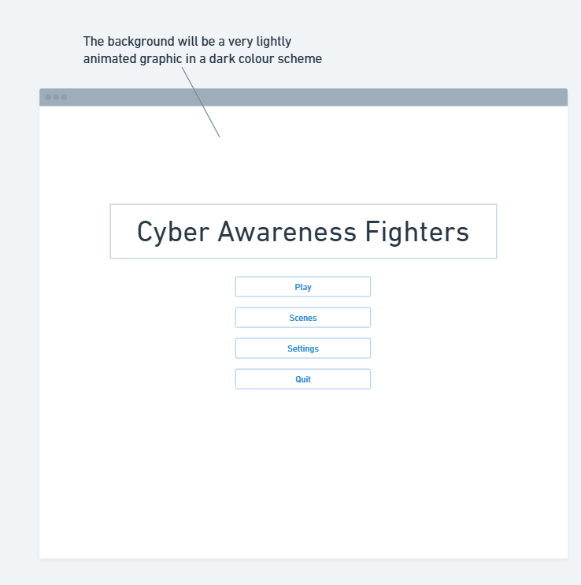
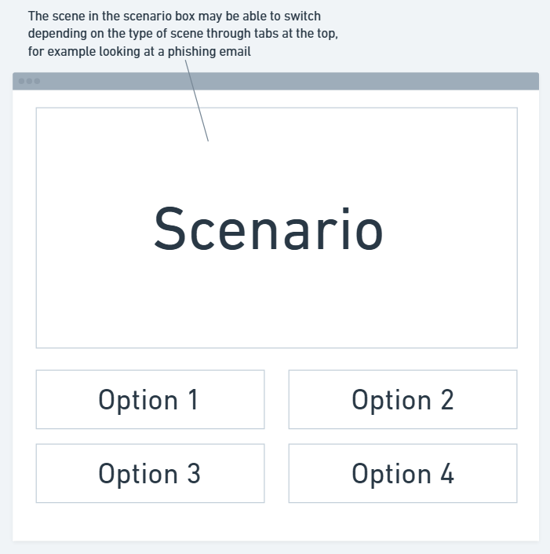
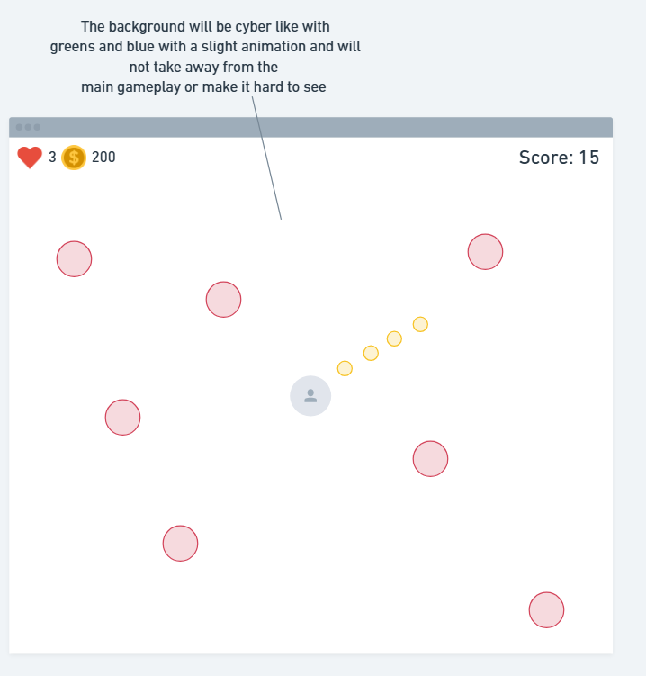

Accessibility options
The primary accessibility will be done through having a text to speech option so that blind players can still participate in the questions portion of the game.

Characters

Player character
The player will control a cyber ship which can shoot bullets and potentially have special power ups.

Enemy
The enemy will be different types of malwares which damage the player when they hit it, they will be locked onto the player and aiming to hit it causing damage to its system.

Level Design

Map/ Environment
The map will be a square area where the player can move around freely and then malware comes in from the edges trying to damage the players ship.

Art and visuals
It will use a cartoon/retro kind of style as this will not be too hard on the users’ eyes while they are playing but won’t be viewed as boring which could happen with a realistic style.

Colour palette
The primary colour palette will consist of black blues, greens and whites as these are commonly associated with computing and cyber, they work well together, and they don’t require a lot of effort to look at which is an important consideration as people may need to play the game for an extended period.

Audio

Music
The game will have an intense but not too hard to listen to piece of music play while they are in the fighting portion of the game and more chill easy to listen to music while answering the questions or on the loading screens, this will also be mutable and their will be a volume slider to make it easier on the users ears if they would like.

Sound effects
There will be sound effects when users click answers to questions as well as when they shoot their gun and lose health in the fighting part of the game.
The answer click will just be a basic clicking correct or wrong sound like Duolingo.
The shooting sound will be a Lazer style sound.
The death sound taking damage sound will be a crash sound like windows.
And the “death” sound will be a crashing sound like a rocket crashing.
The menu will also have clicked sounds which sound like jumping to hyperspace in Star Wars.

Technical details

Game engine
The game engine which will be used is unity, this is because it offers the ability to both port to desktop and web so if the decision was made to do a web port then it will be easier to do it from unity, it also offers plenty of different plug ins for thing like text to speech which will be used for accessibility.

Platform Requirements
The goal will be so that the game can run on any system as some companies or people may not have upgraded systems so ensuring that it is available to run in lower spec systems is vital.

Testing

Player feedback
At the end of each major development users will be bought in to play test the game, this will allow for other perspectives as well as for them to point at any bugs which they have found while playing. The users feedback and bugs will be logged and then fixed as soon as possible, or their feedback will be ignored if needed.

